FAER Video Scoring Analysis (Preliminary)
Raters: 1=Jack; 2=Eddie
Time Points: 0=baseline; 1=interval; 2=final
Global Rating Scale: 1-5; 5=highest possible
Research Team: Mariano, Howard (Senior), Harrison, Shum, Kim, Kan, Ganaway, Kou (? If more stats help needed)

SUMMARY FOR TOTAL SCORE (30 PTS POSSIBLE)
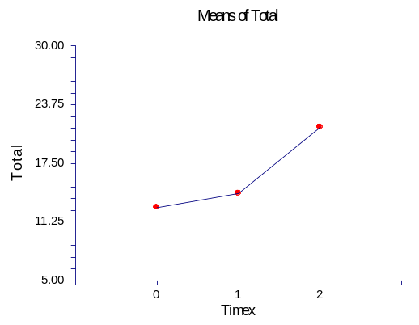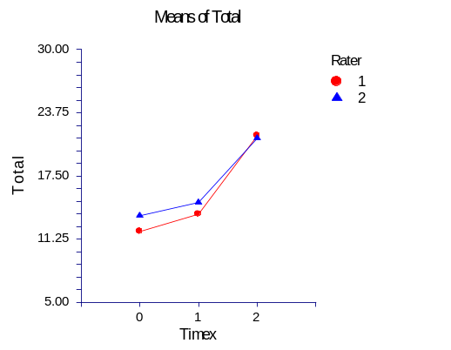
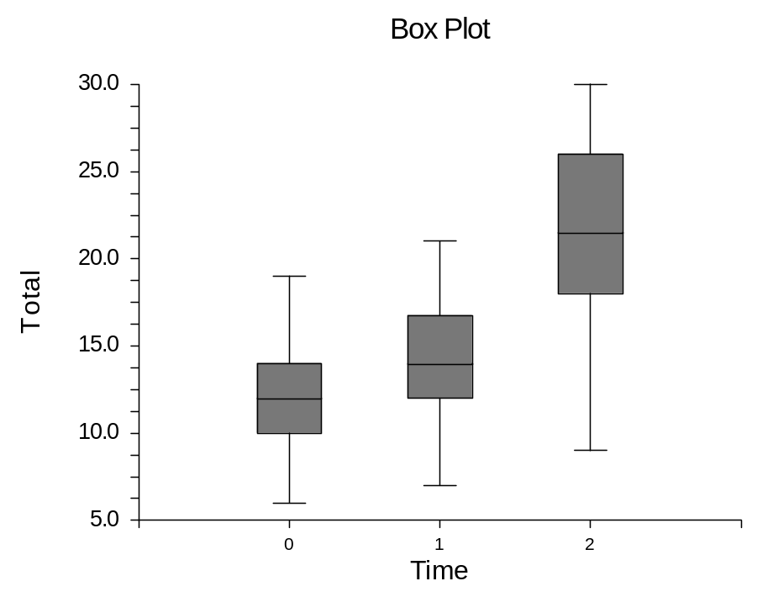
Overall p<0.001; no difference between raters
Tukey-Kramer Multiple-Comparison Test

Response: Total
Term C: Timex

Alpha=0.050 Error Term=BC(A) DF=60 MSE=19.14861 Critical Value=3.3987

Different From
Group Count Mean Groups
0 64 12.78125 2
1 64 14.29688 2
2 64 21.34375 0, 1

SUMMARY FOR PROCEDURAL ELEMENTS (20 PTS POSSIBLE)
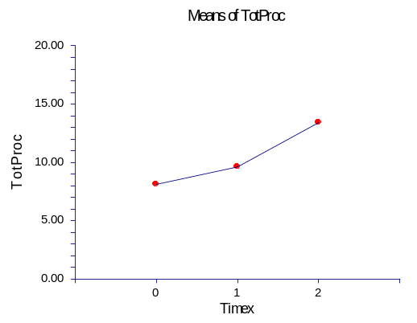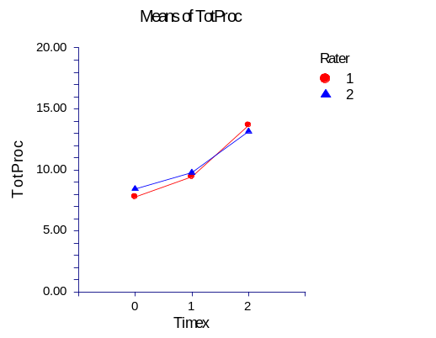
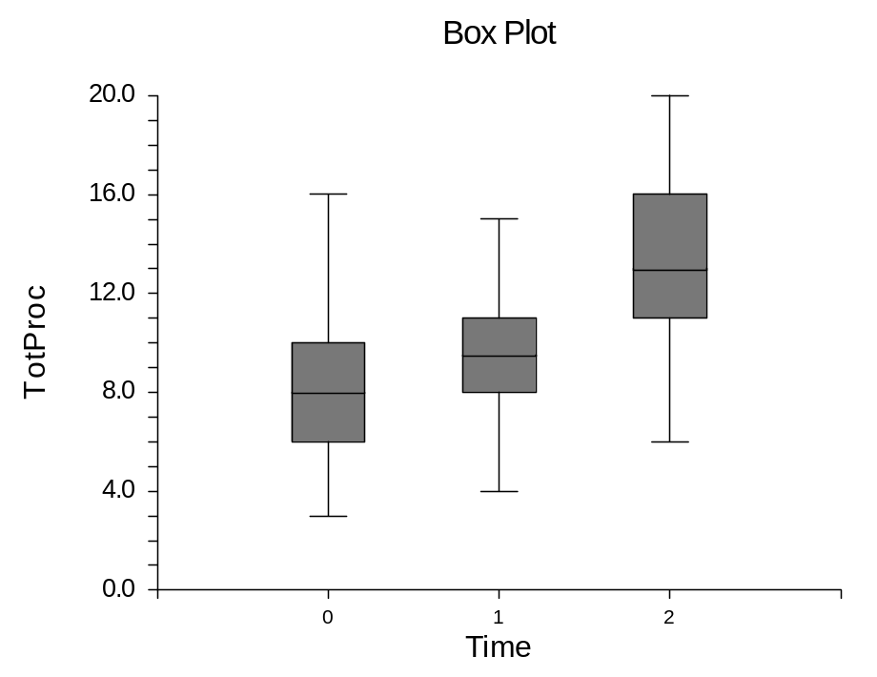
Overall p<0.001; no difference between raters
Tukey-Kramer Multiple-Comparison Test

Response: TotProc
Term C: Timex

Alpha=0.050 Error Term=BC(A) DF=60 MSE=9.413195 Critical Value=3.3987

Different From
Group Count Mean Groups
0 64 8.109375 1, 2
1 64 9.609375 0, 2
2 64 13.40625 0, 1

SUMMARY FOR ERGONOMIC ELEMENTS (10 PTS POSSIBLE)
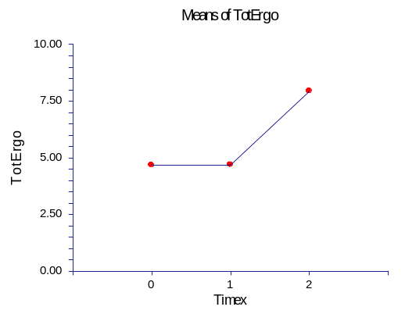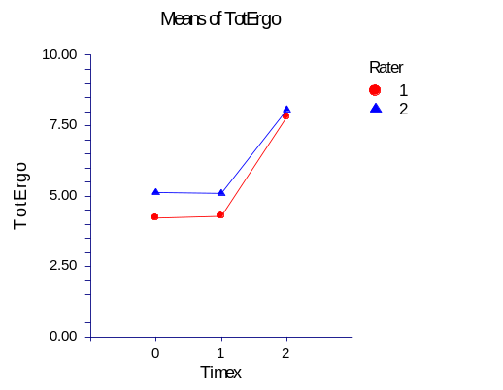
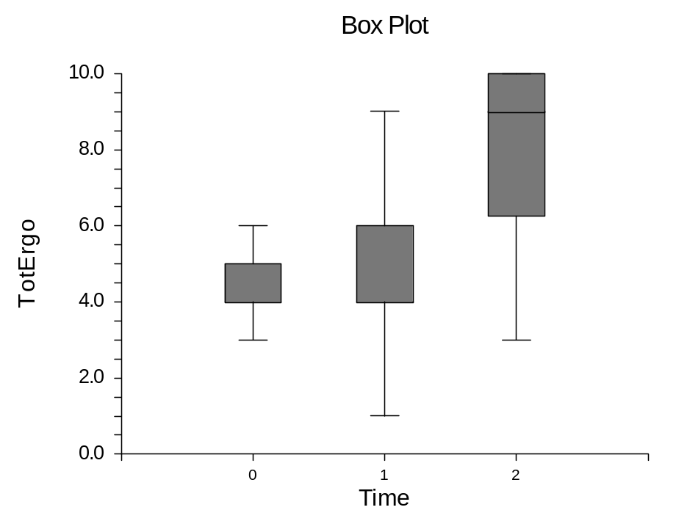
Overall p<0.001; no difference between raters
Tukey-Kramer Multiple-Comparison Test

Response: TotErgo
Term C: Timex

Alpha=0.050 Error Term=BC(A) DF=60 MSE=5.41875 Critical Value=3.3987

Different From
Group Count Mean Groups
0 64 4.671875 2
1 64 4.6875 2
2 64 7.9375 0, 1

SUMMARY FOR GLOBAL RATING SCALE (5 PTS POSSIBLE)
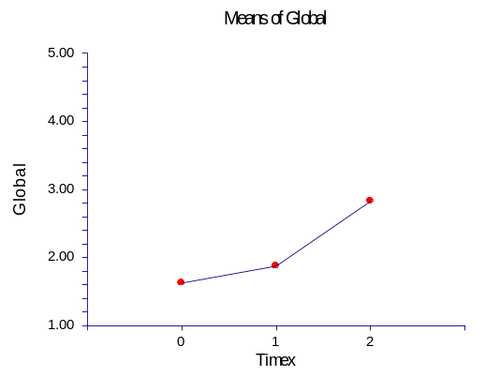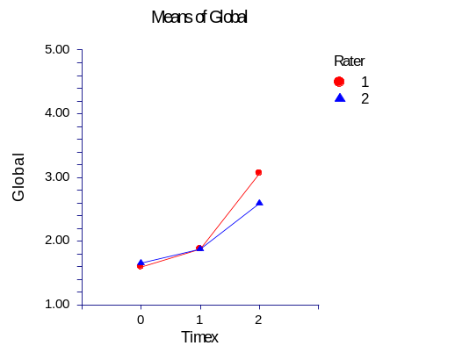
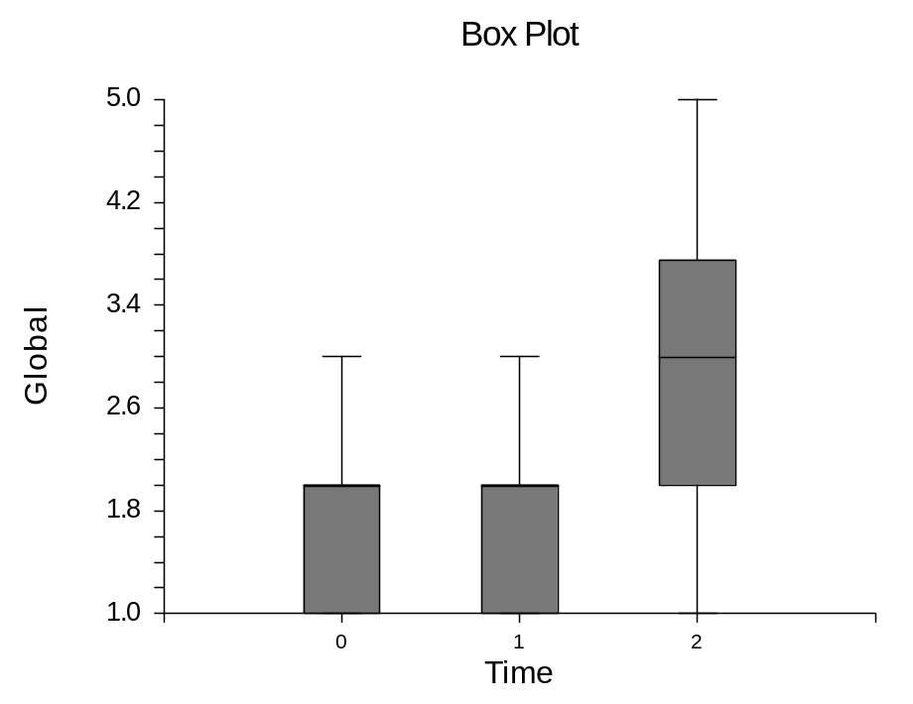
Overall p<0.001; no difference between raters
Tukey-Kramer Multiple-Comparison Test

Response: Global
Term C: Timex

Alpha=0.050 Error Term=BC(A) DF=60 MSE=0.5118055 Critical Value=3.3987

Different From
Group Count Mean Groups
0 64 1.625 2
1 64 1.875 2
2 64 2.828125 0, 1

